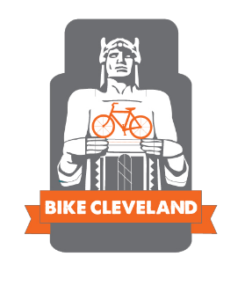
FOR IMMEDIATE RELEASE

Contact:
Rob Thompson
Bike Cleveland
rob@bikecleveland.org
(216) 245-3101

BIKE CLEVELAND TO HOST BIKE AWARENESS RALLY MARCH 12TH IN BRECKSVILLE
Action comes in the wake of “Not Guilty” verdict for motorist who killed two local cyclists.
March 8, Brecksville: Bike Cleveland calls on the cycling community and the region at large to turn out for an awareness rally focused on the rights and mistreatment of people on bikes. The rally will take place this Saturday, March 12th, at 11a.m. at Brecksville Town Square (NW corner of Route 82 and Route 21 in Brecksville, OH).

The killings of Matt Billings and Jim Lambert, and the serious injury of three other cyclists in Brecksville last September -- and the full acquittal of area man Timothy Wolf, who killed and injured these individuals when he illegally turned into their path underscores the dangerous disconnect which exists between people on bikes and other road users. The incident has enraged local cyclists and sparked a call for action from the cycling community.

More and more people are choosing to ride a bike for transportation and recreation. People should be able to do so without fear of injury or death. Yet, in 2015, 27 people on bikes were killed by motorists in the state of Ohio; this is a 108% increase over 2014 fatality rates. This is unacceptable.

All too often the dangerous actions of people in cars are diminished, both through passive cultural means inherited over generations of car culture, and actively by those who attempt to shift the blame to the victims of crashes. Crashes that can be avoided if people take the act of driving vehicles capable of great destruction more seriously. Yet as it stands, we have a culture that allows people to kill others without repercussion. Education and awareness are the keys to addressing this problem, and that is one goal of the rally.

“You are not excused from your negligent actions merely because they take place from behind the wheel of a car or truck,” said Jacob VanSickle, Executive Director of Bike Cleveland. “There is a culture of forgiveness for careless motorists when the opposite should be happening. We need to establish a culture that insists on responsibility for one’s actions. The value of a person is not diminished merely because they choose an alternative mode of transportation to a car. People on bikes are valuable members of our society; mothers and fathers, friends and family.” VanSickle concluded.

The loved ones of Matt Billings and Jim Lambert will be present to share their stories and messages, and we invite other members of the cycling community to speak to their experiences. Bike Cleveland will be on hand to share safe cycling tips and provide updates on current initiatives aimed at addressing the current inequality present on our roadways.

About Bike Cleveland

Bike Cleveland is a 501(c)(3) non-profit, and the leading advocacy organization for bicycles and pedestrians in the Greater Cleveland area. With the goal of making Greater Cleveland a better place to live and ride, Bike Cleveland works to build livable communities by promoting all forms of cycling, and advocating for the rights and equality of the cycling community.

###

